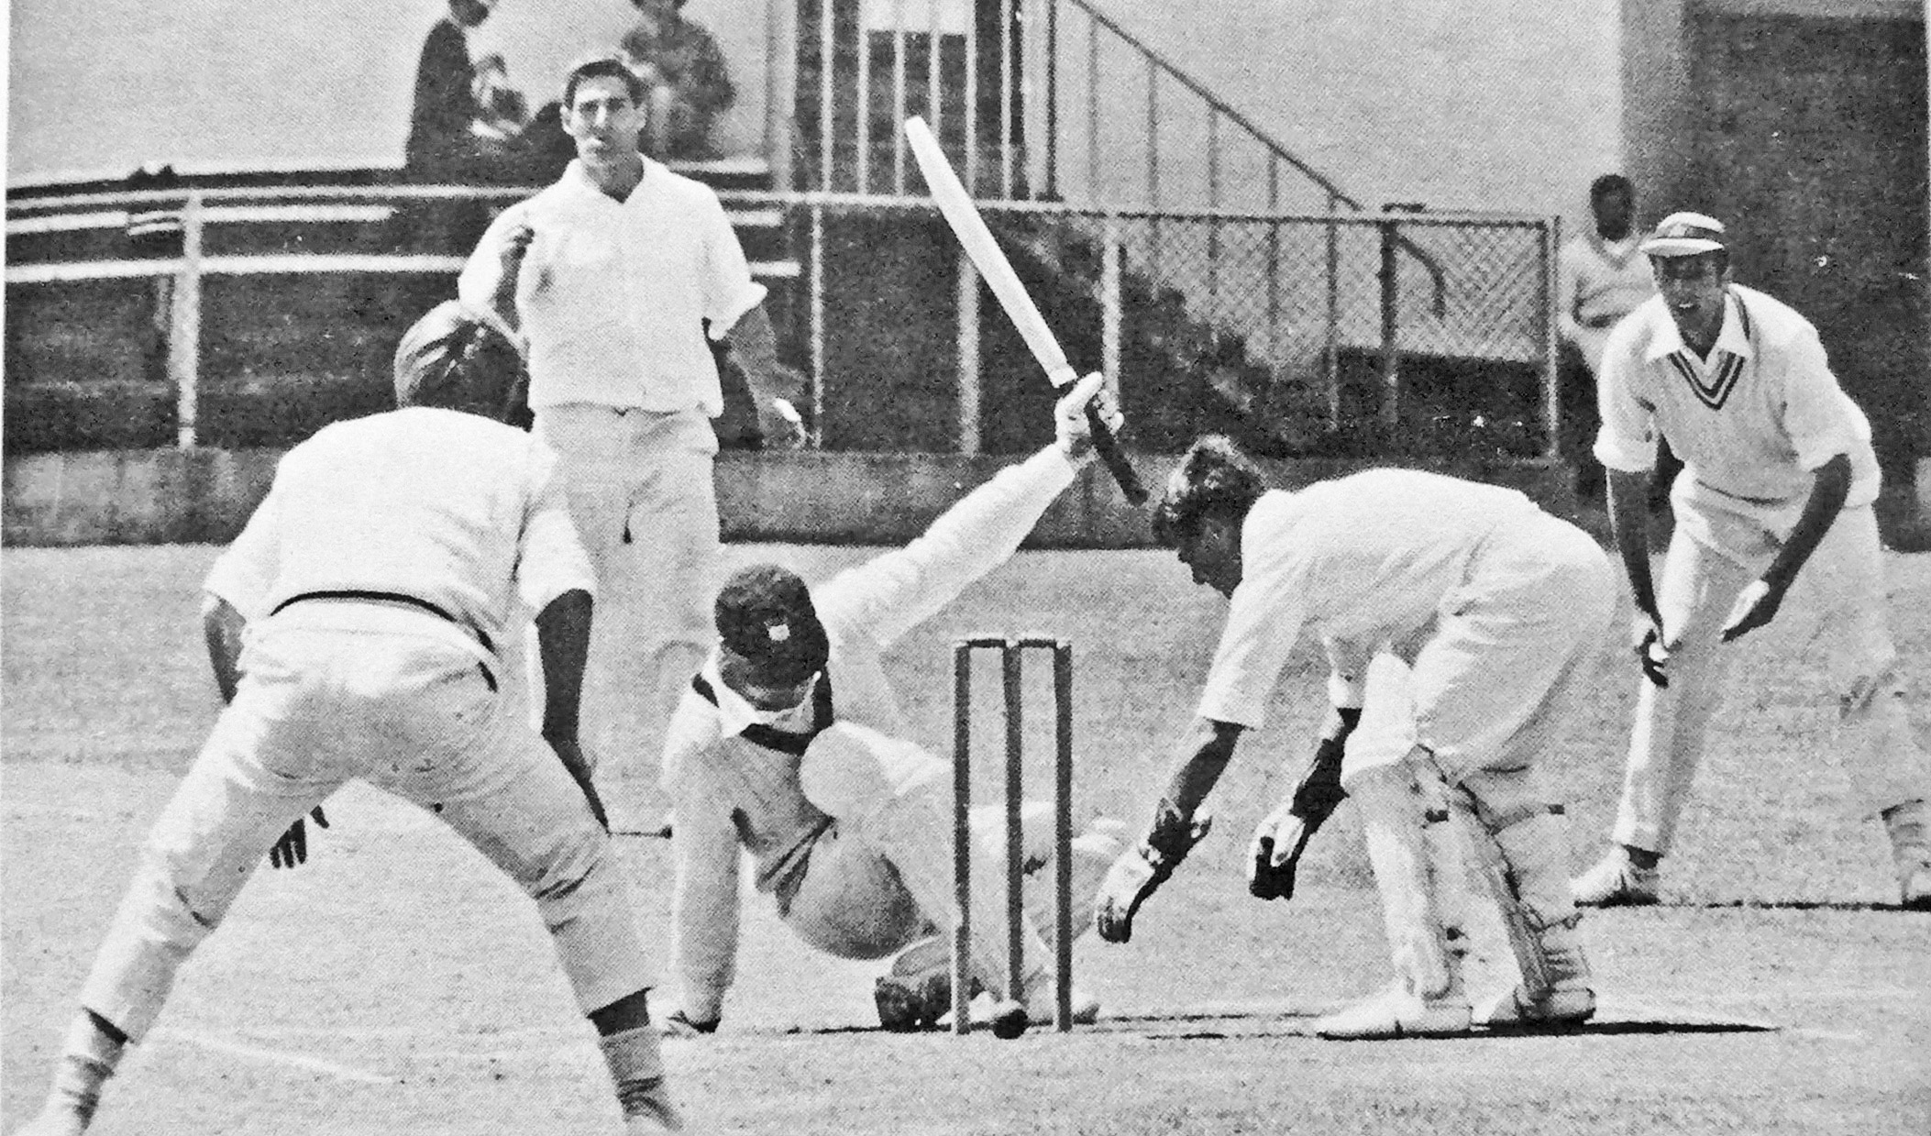

**John McIntyre slips while sweeping. Brian Isherwood keeper, Maurice Ryan at slip and Barry Hadlee at short cover.**

**Canterbury v Auckland 3 January 1972 Lancaster Park.**

**Auckland 281 and 186/6 declared. Canterbury 266 and 203/6 Canterbury won by four wickets.**